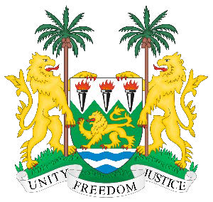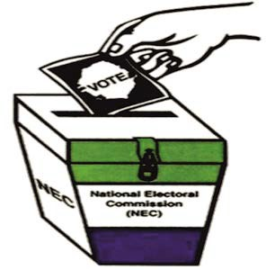
Political Party/Candidate Agents

Must...
May...
- Observe the polling exercise on behalf of her/his party/candidate

- Bring questionable or irregular activities to the attention of the Presiding Officer

- Observe the counting proce- dures sign the Reconciliation and Result Forms

- Obtain a copy of the Reconcilia- tion and Result Forms

- Be asked to leave the Polling Station if s/he is not complying with his/her obligations

- Write/record the name of voter, the voter ID number and address once the Voter Identificaton Officer announces this informa- tion
- Comply with the guidelines and the code of conduct issued by NEC

- Comply with the limits on number of agents in a polling station – at a presidential election this is two per political party

- Display visibly their accreditation badges/ID Cards issued by the NEC and make sure that it clear- ly refers to the specific Polling Centre

- Not interfere with the polling and counting processes in any way

- Not display any indicator that s/he represents particular party/ candidate

- Not touch sensitive materials such as ballot papers

- Not touch, collect or hold Voter ID cards

